Successful career guidance model set to become more widespread
More schools, more companies, more opportunities – association set up for the SchulePlus program
Haiger, August 27, 2026
What started out as a project at the Johann-Textor school in Haiger has turned into a successful model for career guidance. SchulePlus brings together young people and companies that take on trainees – for a period of up to two years while these young people are still at school. The next big step is now being taken – the registered association SchulePlus e. V. is being established to give the ever-expanding network a professional organizational structure. In this way, the foundations are being laid for safeguarding the concept on a long-term basis, developing it further and expanding it beyond the region. As one of the program’s very first supporters, the Friedhelm Loh Group, through Rittal, is playing an active role in driving developments forward.

SchulePlus was the brainchild of Alexander Schüler, who is currently the acting principal of the Johann-Textor school in Haiger. His idea was that careers guidance should provide young people with more than brief, selective insights, and instead give them enough time to properly experience a particular occupation and the everyday work it involves. Through collaboration with companies in the region, this idea was turned into a model that creates close ties between schools and businesses.

SchulePlus has come a long way since its earliest days in Haiger. Over fifty schools in Hesse have now adopted the concept. Back in November 2025, the Hessian Ministry of Education and Cultural Affairs (HMKB), the Hessian Ministry for Economic Affairs, Energy, Transport, Housing and Rural Areas (HMWEVW), the Lahn-Dill administrative district, and representatives from businesses and chambers of trade and industry signed a joint declaration of intent. The aim is to establish SchulePlus as a blueprint for the whole of Hesse and to roll out the model on an even wider scale.

When potential counts for more than a certificate
The SchulePlus principle goes well beyond the scope of a conventional short internship. School students first decide on a skilled occupation and are paired up with a suitable company. They then spend up to two years working at that company at least once a week, carrying out tasks that are similar to the actual work that apprentices do.

The school students can therefore find out whether that job really is for them – and they can show what they are made of, too. The companies get to know their potential future apprentices and find out about their capabilities and what motivates them. In this everyday working environment, young people may well demonstrate qualities that are not always apparent in application documents or from the grades they have achieved at school. As a basic principle, there is an actual training position associated with every SchulePlus place, so if things work out well, the school student can go straight into an apprenticeship.

From personal commitment to a professional structure
As the success of SchulePlus has grown, the work associated with it has, too. Companies need to be brought on board and incorporated into the program, schools need to be advised, young people and businesses need to be paired up, and consistent quality standards need to be ensured. During the start-up phase, the people involved carried out these tasks with a great deal of personal commitment alongside their normal work. Given the growing network, however, a long-term structure is now needed.

The new SchulePlus e. V. association is laying the necessary foundations and becoming the central link between schools, companies, school students, parents, chambers of trade and industry, organizations, politicians, and other stakeholders. Besides helping with the implementation of the program, SchulePlus e. V. coordinates the network, pools experience, ensures quality standards are maintained, and provides support for rolling out the model on a wider scale. There are also plans for full-time structures in the longer term.

Taking responsibility and pulling together
The Friedhelm Loh Group and Rittal have been supporting SchulePlus since the early stage of the project. As one of the first companies to sign up to the program, Rittal has helped to transfer the concept devised at the Johann-Textor school to practical business environments and develop it further.

“Young people need guidance, prospects, and the opportunity to discover their own strengths. By bringing schools and companies together, SchulePlus offers school students the chance to gain practical experience of the working world. We see this as a direct part of our entrepreneurial and social responsibility. That’s why we’ve been fully on board with this initiative, supporting it right from the outset. Setting up the association means the foundations are being laid for rolling out this model far beyond our own region. A good idea isn’t enough on its own, though. What we all need to do now is take responsibility, pitch in together and expand SchulePlus to other areas,” says Prof. Friedhelm Loh, owner and CEO of the Friedhelm Loh Group.

Proof that commitment to the program leads to genuine prospects can be found in the Friedhelm Loh Group itself, as Rittal has already secured a number of apprentices through SchulePlus. The model therefore offers benefits for school students and businesses alike. Young people get genuine insight into the working world at an early stage and can make an informed decision to embark on an apprenticeship. Companies, meanwhile, get to know potential young employees over an extended period and can find out all about their capabilities and what motivates them.

Even when the joint declaration of intent was signed back in November 2025, Prof. Loh spoke in favor of developing SchulePlus beyond the region.

_________________
SchulePlus e. V. – the network
SchulePlus e. V. has been set up by companies, organizations, and institutions.

Founding companies:
Carl Cloos Schweisstechnik GmbH, Diakonie Bethanien gGmbH, Franz Hof GmbH, Isabellenhütte Heusler GmbH & Co. KG, Klingspor AG, Kühne + Nagel (AG & Co.) KG Zweigniederlassung Haiger, Lebensmittel Kai Göbel e. K., Friedhelm Loh Group, Stadt Haiger, Zweidick Werkzeugbau GmbH

Organizations and institutions:
Employment agency, Handwerk Mittelhessen e. V. (the trade association for Central Hesse), the Lahn-Dill Chamber of Commerce and Industry, the Lahn-Dill/Wetzlar District Trade Association, the Lahn-Dill administrative district, the Federation of Hessian Business Associations

Members of the advisory board:
The Hessian Ministry of Education and Cultural Affairs (HMKB), the Hessian Ministry for Economic Affairs, Energy, Transport, Housing and Rural Areas (HMWEVW), the Limburg-Weilburg state school board

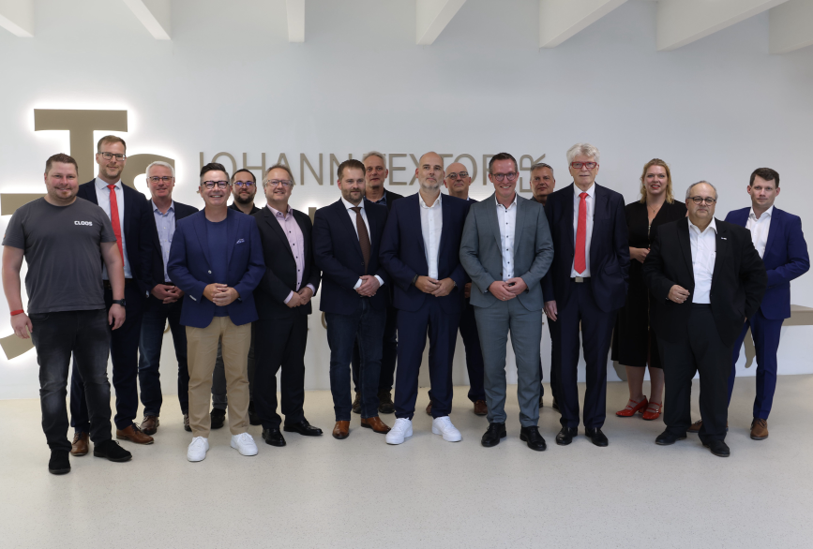
Image 1
A shared commitment to students’ professional futures: Companies, associations, and institutions – along with an advisory board from the State of Hesse – are taking SchulePlus to the next important level by establishing the association.

May be reproduced free of charge. Please cite the Friedhelm Loh Group as the source, as well as Joachim Jung.

Friedhelm Loh Group

The companies within the globally successful Friedhelm Loh Group invent, develop, and produce innovative system solutions for industry, IT, and energy, as well as other industrial sectors worldwide. They are regarded as some of the foremost companies in their respective sectors.
Rittal, Rittal Software Systems (Eplan, Cideon) and Rittal Automation Systems (RAS, Ehrt, Alfra) combine their hardware and software expertise to streamline, optimize and industrialize processes across the entire value chain of their customers including their IT infrastructure—from panel building and switchgear manufacturing, machine building to manufacturing companies or the energy sector. Stahlo and LKH complete the portfolio with their end-to-end manufacturing expertise with the modern materials steel and plastic.
The group operates worldwide, with thirteen production sites and ninety-four international subsidiaries. It has 12,900 employees and posted revenues of 3.2 billion euros in fiscal 2025. In 2023, the Friedhelm Loh Group was presented with the “Best Place to Learn” and “Employer of the Future” awards. In 2026, Rittal was awarded the Top 100 Seal as one of Germany’s most innovative medium-sized companies for the fifth time in a row. In 2025, the Rittal Haiger plant was awarded overall victory in the “Factory of the Year” benchmark competition and is thus one of Europe’s best factories.
For more information, visit www.friedhelm-loh-group.com.

Corporate & Brand Communications

Cornelia Müller Hans Robert Koch Steffen Maltzan
Tel. +49 2772 505-2527 Tel. +49 2772 505-2693 Tel. +49 2772 505-2680
E-Mail: mueller.co@rittal.de Mail: koch.hr@rittal.de Mail: maltzan.s@rittal.de

Friedhelm Loh Group, Rudolf-Loh-Straße 1, 35708 Haiger
www.friedhelm-loh-group.de

